 | CONSUELO BRADLEY
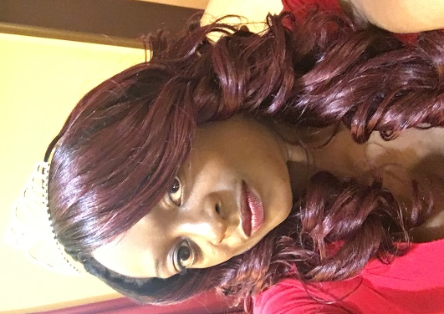 | 3114 Cabot St.  Montgomery, Al. 36110  consuelo_bradley@hotmail.com  www.1eliteplan.com  1-334-954-9743
Immediately Available: Event Planner with a Passion for Expertly Coordinated Functions!

Career Profile:

Talented Event Coordinator extensively experienced in all aspects of project management such as planning, organizing, motivating, and controlling resources, procedures, and protocols to ensure the continuity of special and seasonal events planned are well-organized, effective, and efficient. Fifteen years of event management background including 6 years of customer service, 9 years as event planner and licensed wedding planner. An administrative professional skilled in marketing, able to cultivate effective community relations and offer excellent communication and computer tasks efficiently. Meets deadlines and works with a high level of multicultural awareness and adaptability.

Seeking a position as an Event Planner in a fast-paced environment where my creative skills and abilities will contribute to the tremendous growth of the organization.
Professional Strengths:
- Possess excellent written and verbal communication skills
- Extensive knowledge of event planning in corporate environment
- In-depth knowledge of marketing and public relations
- Excellent project management and organizational skills
- Ability to manage time efficiently and handle multiple tasks
- Possess good negotiation and budget management skills
- Detail-oriented with ability to perform tasks under pressure
- Familiar with basic Microsoft Office applications
- Self-starter, staff management with excellent interpersonal skills
Professional Experience:

2010 – Present Elite Event Planning www.1eliteplan.com
Website Developer

- Creating functional and attractive website for clients to browse
- Identifying potential site users and creating appealing websites
- Studying clients' business, market trends and competitors' websites
- Constructing website layouts and user-friendly design
- Testing site functional on all web browsers
- Testing and updating sites as needed
- Designed and maintained business websites for retail and service sales
- Ensured websites are easy to navigate and upload on the Internet
- Used scripting languages for creating surveys, contests, and forms

2014 – 2016 Advantage Sales & Marketing Product & Merchandise Demonstrator
Lead Event Specialist

- Supervise culinary and merchandising demonstrations
- Manage daily office duties
- Coordinate with all store department managers to achieve optimal demonstration activities
- Prep merchandise and food for daily demonstrations
- Handle vital administrative responsibilities
- Supervise other event specialist during demonstrations

2010 – Present Elite Event Planning Wedding & Special Event Planning
Owner

- Research and development of targeted demographic
- Obtain all licenses and zoning restrictions for events
- Designer and Webmaster of online marketing site
- Facilitate weddings and special events
- Create personalized online calendar for client events
- General Office Manager
- Customer Service Representative
- Create master timeline and flowchart for all event related activities
- Create online and local marketing campaign
- Categorize Budget list to ensure on budget results of event
- Negotiate contracts with participating vendors
- Prepare design proposals
- On site Event Management
- Prepare all tax forms and applicable documentations

2007- 2009 The Palace LLC. Banquet Hall & Event Planning Center
Owner

- Research and development of location vetting
- Completed and mailed bills, contracts, policies, invoices and checks.
- General Office Manager
- Customer Service Representative
- Facilitated in house events
- Planned and executed events and marketing programs, producing three times target number of qualified leads.
- Increased credibility and client awareness by developing technical/non-technical marketing collateral and presentations, public relations campaigns, articles and newsletters.
- Assigned tasks to associates, staffed projects, tracked progress and updated managers, partners and clients as necessary.
- Worked closely with all product development departments to create and maintain marketing materials for sales presentations and client meetings.
- Accessed computerized financial information to answer questions related to specific accounts.
- Matched purchase orders with invoices and recorded the necessary information.
- Reviewed files, records and other documents to obtain information and respond to requests.
- Increased credibility and client awareness by developing technical/non-technical marketing collateral and presentations, public relations campaigns, articles and newsletters.
- Developed and executed marketing programs and general business solutions resulting in increased company exposure, customer traffic, and sales.
- Worked closely with all product development departments to create and maintain marketing materials for sales presentations and client meetings.

